Q1. Histogram and Boxplot
Histogram of Quiz Score
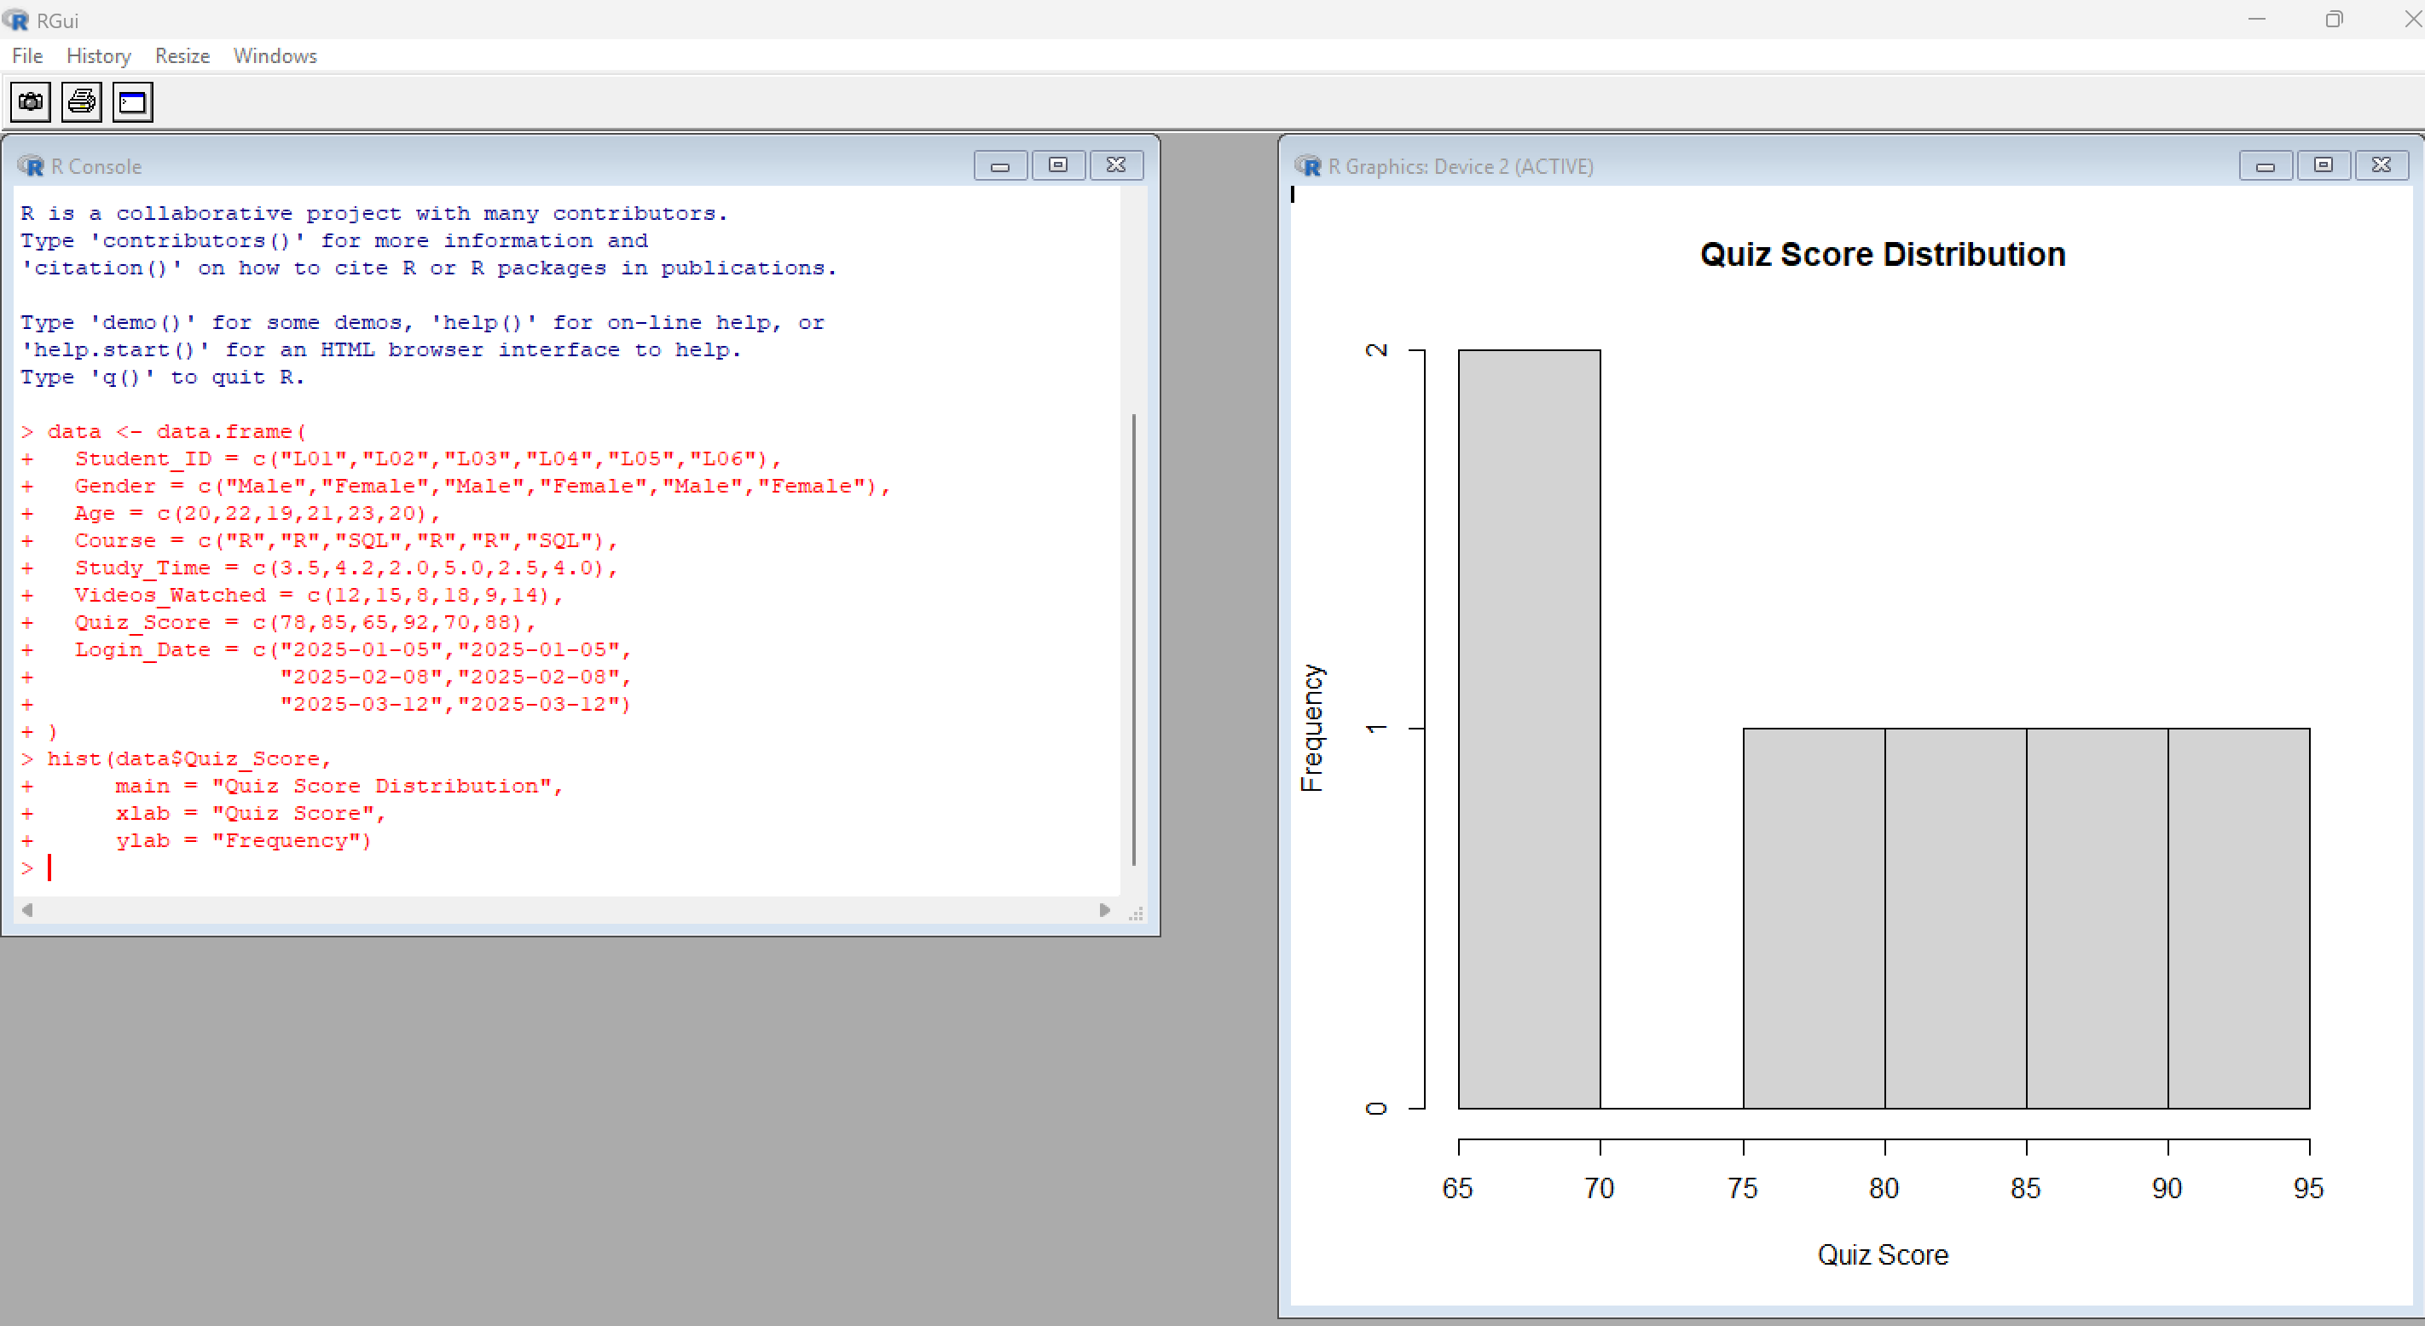
Boxplot by Course
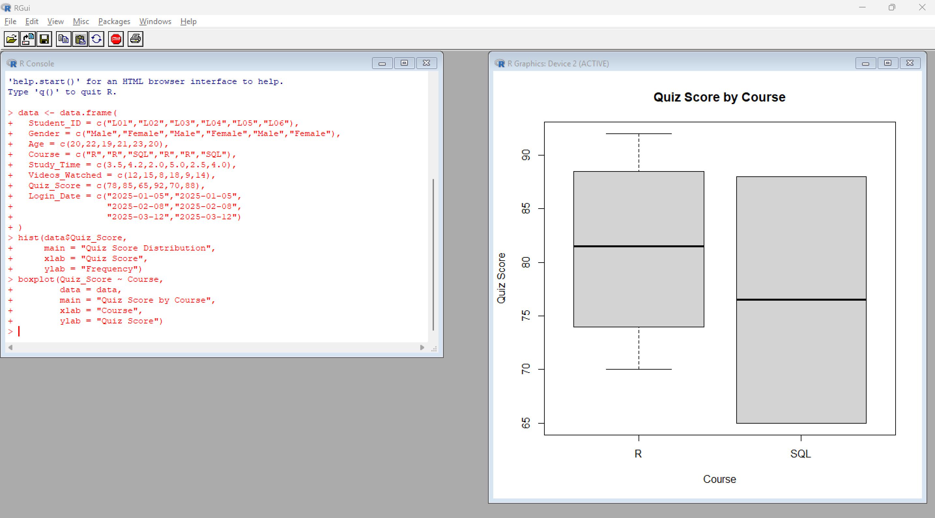

Q2. Scatter Plot – Study Time vs Quiz Score
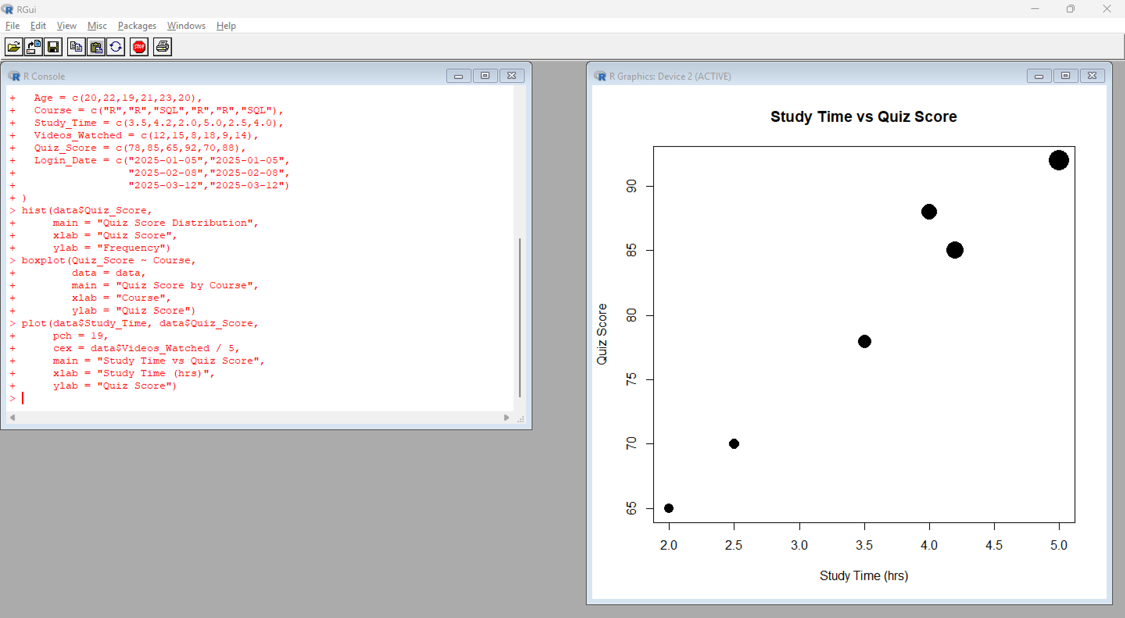
With Transparency
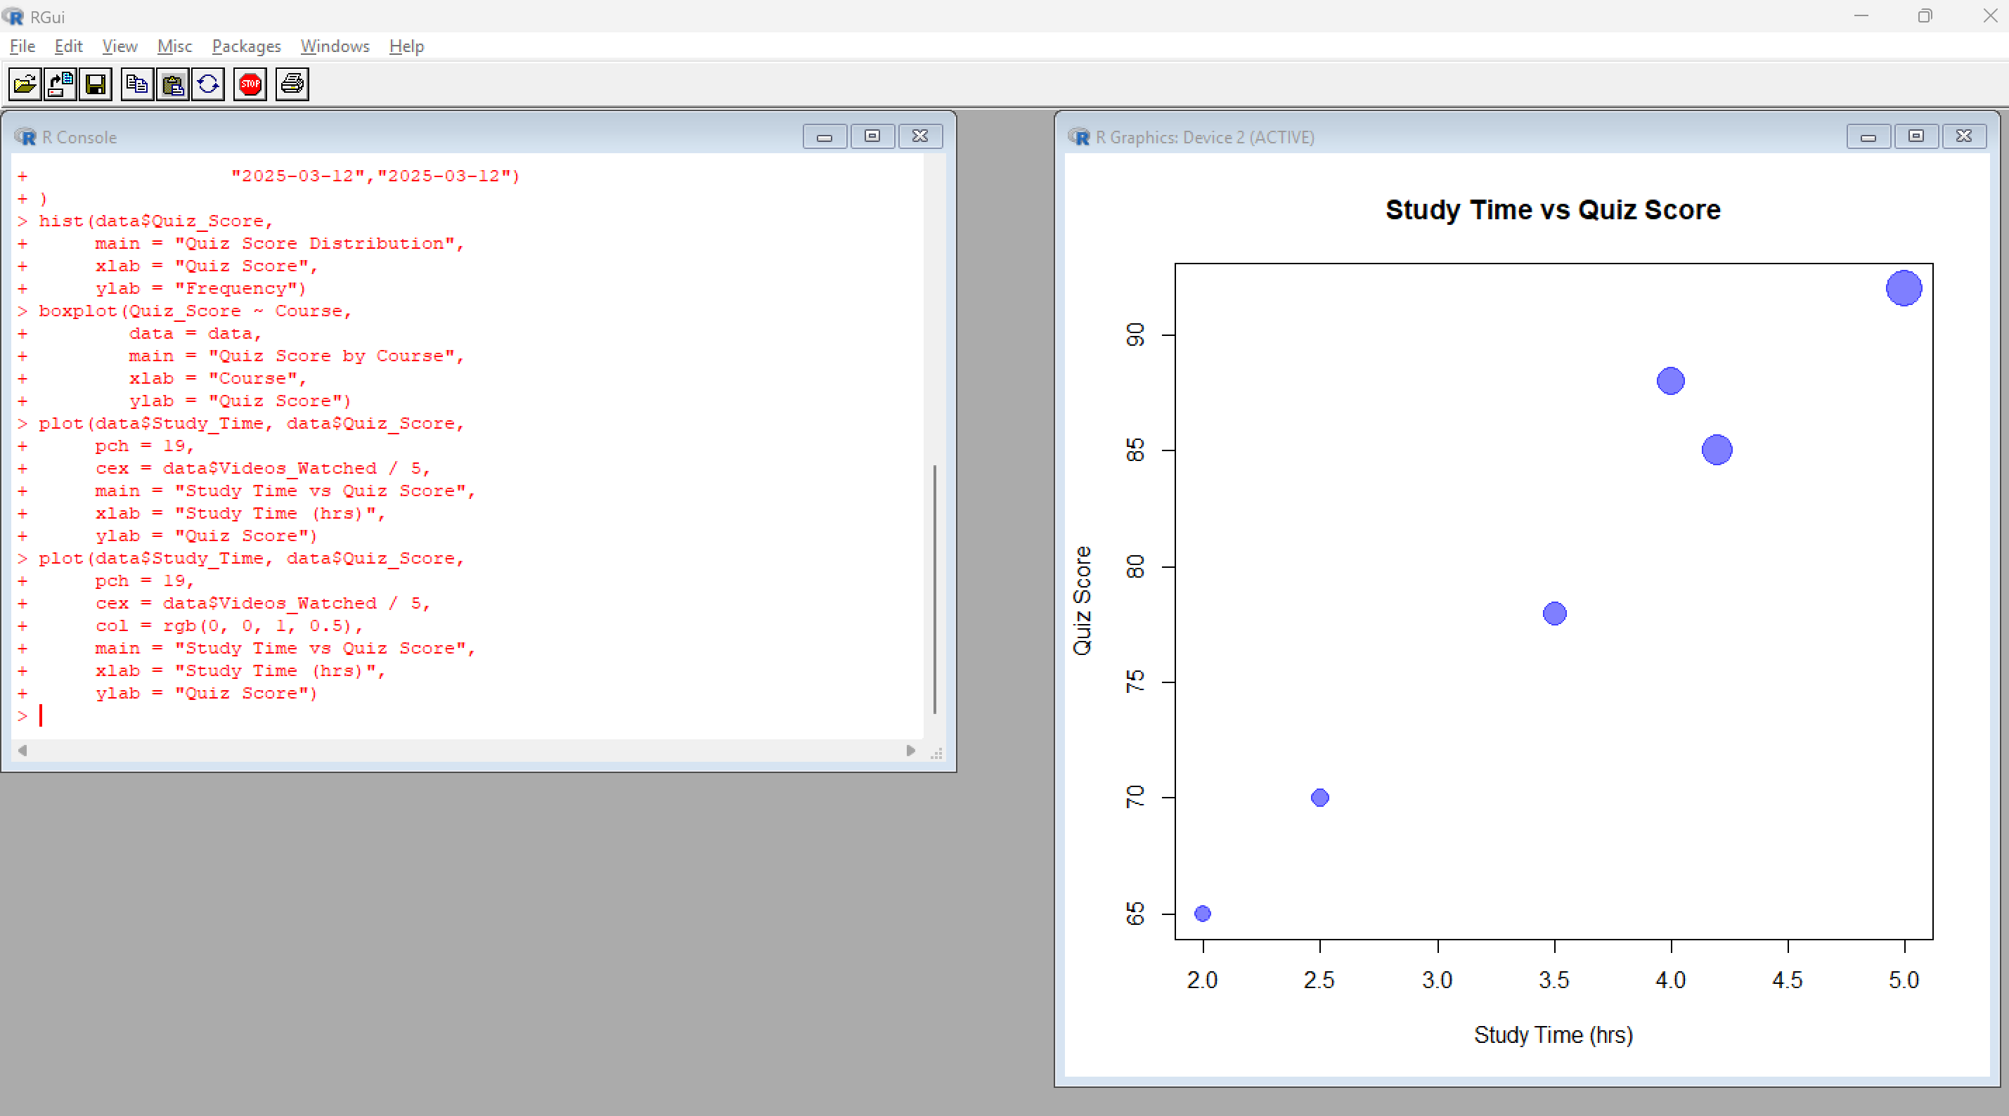

Q3. Monthly Average Quiz Score + Moving Average
Convert Login_Date to Date
data$Login_Date <- as.Date(data$Login_Date)
Calculate monthly average

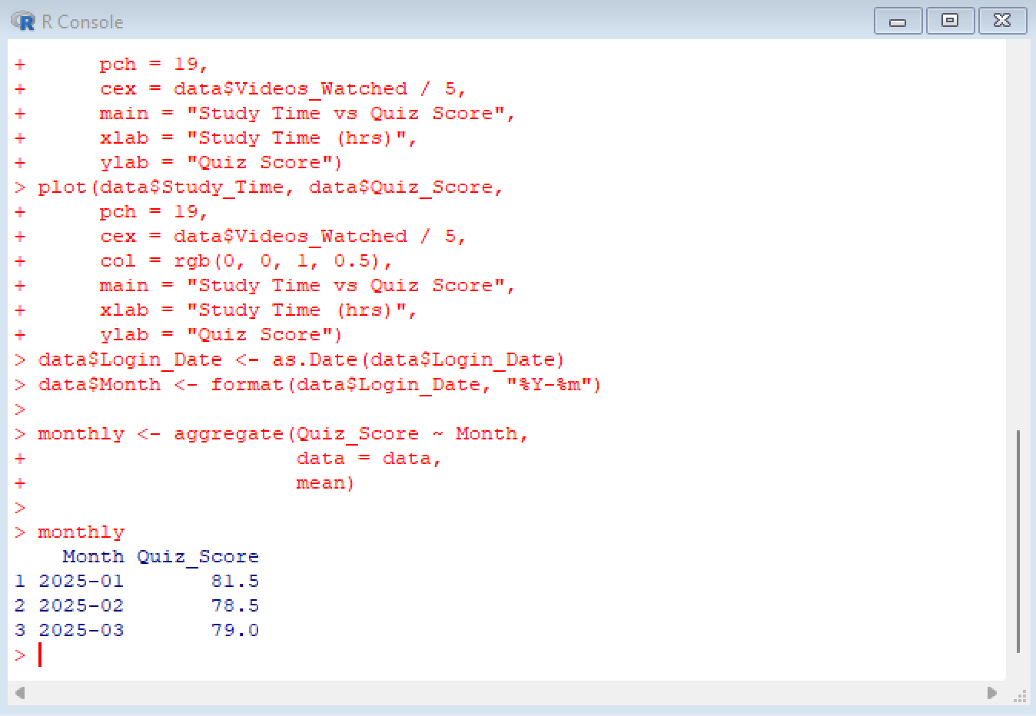
4.
